MAWLANA BHASHANI SCIENCE AND TECHNOLOGY UNIVERSITY
SANTOSH, TANGAIL-1902



DEPARTMENT OF INFORMATION AND COMMUNICATION TECHNOLOGY
Lab Report

Lab Report No : 05
Lab Report on : Study of Fourier Transform, Inverse Fourier Transform, and DTFT
using MATLAB.
Course Title : Digital Signal Processing Lab
Course Code : ICT-3206
Submitted By | Submitted To
Name: Kuldip Saha Mugdha  ID: IT-22018  3rd Year, 2nd Semester  Session: 2021-2022  Dept. of ICT, MBSTU | Dr. Mst. Nargis Akter  Professor  DEPARTMENT OF INFORMATION AND COMMUNICATION TECHNOLOGY  MAWLANA BHASHANI SCIENCE AND TECHNOLOGY UNIVERSITY

Date of Performance: 01/12/25 Date of Submission: 12/01/26
Introduction:
Fourier analysis is a fundamental tool in Digital Signal Processing that represents signals in the frequency domain. Fourier Transform (FT) is used for continuous-time signals, while Discrete-Time Fourier Transform (DTFT) is used to analyze discrete-time systems. This experiment demonstrates Fourier Transform, Inverse Fourier Transform, and DTFT of given signals using MATLAB.

Objective:
- To find the Fourier Transform and Inverse Fourier Transform of a given signal.
- To obtain the Fourier Transform of a time-domain signal and analyze its spectrum.
- To evaluate and plot the DTFT of a discrete-time transfer function.

Theory:
The Fourier Transform of a signal $x(t)$is defined as
$$X(ω)=\int_{-∞}^{∞}{x(t)}e^{-jωt}dt$$
The Inverse Fourier Transform recovers the original signal from its frequency representation.
The DTFT represents discrete-time signals in the frequency domain and is widely used for frequency response analysis.

MATLAB Code:
Program 1: Fourier Transform and Inverse Fourier Transform
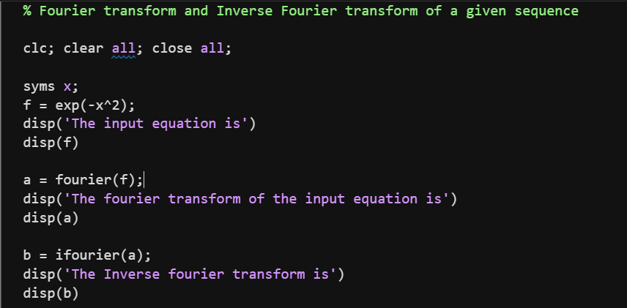

Output:
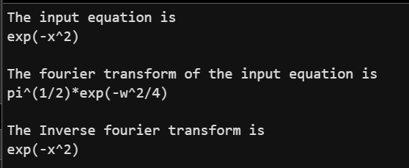
Program 2: Fourier Transform of a Time-Domain Signal
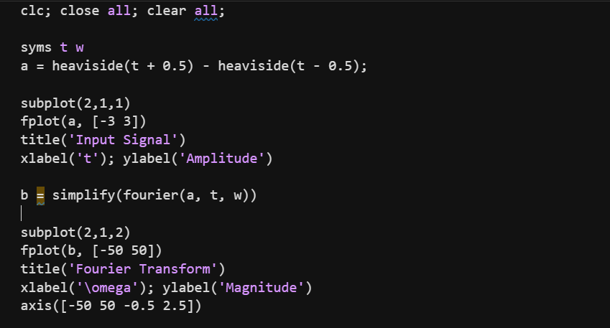
Output:
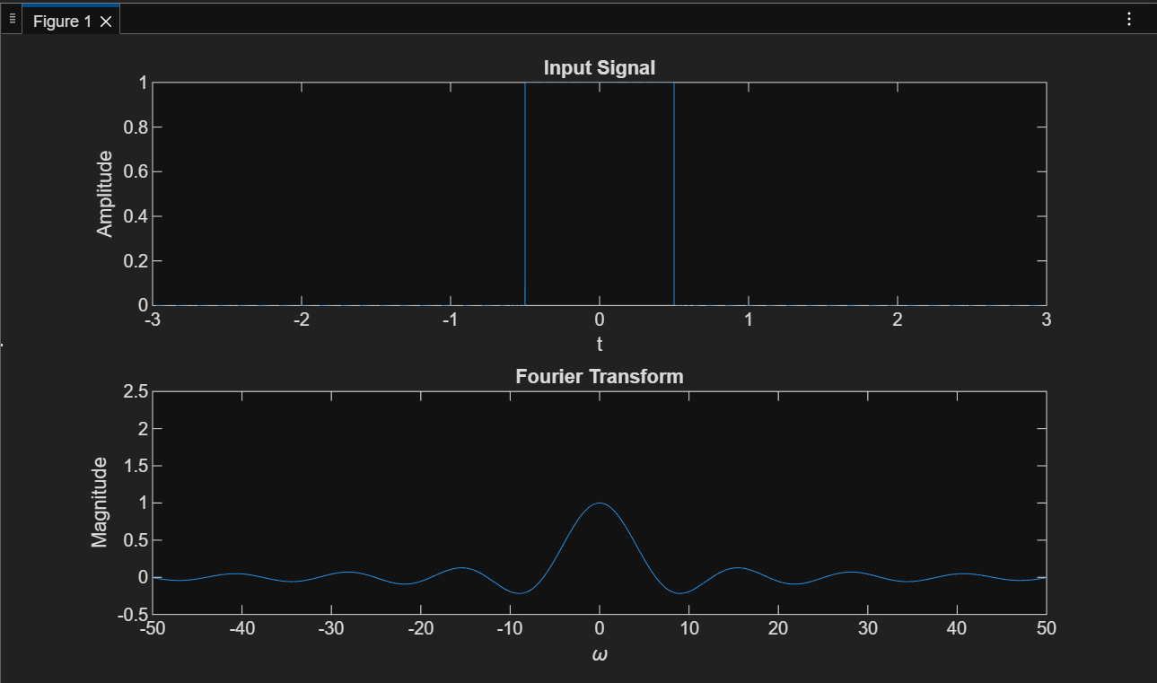
Program 3: DTFT of a Discrete-Time Transfer Function
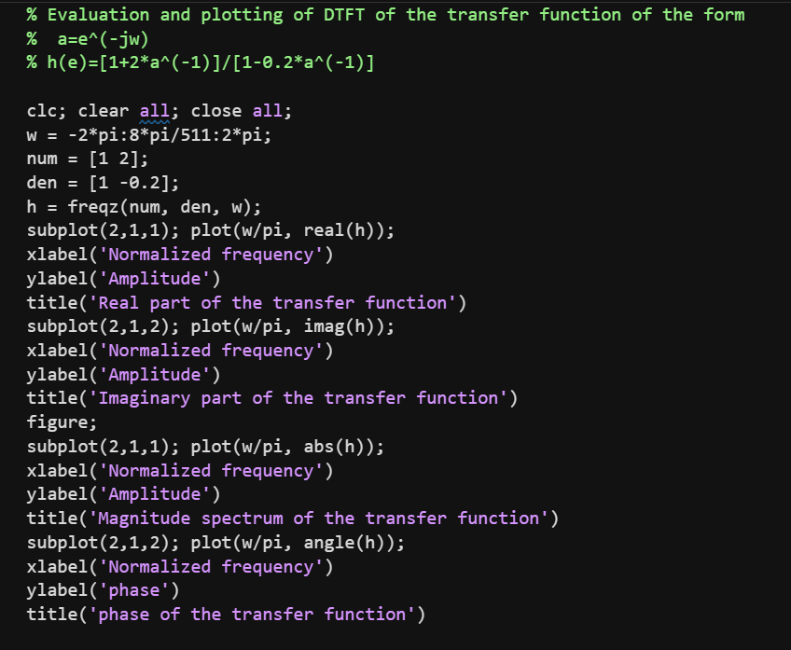
Output:
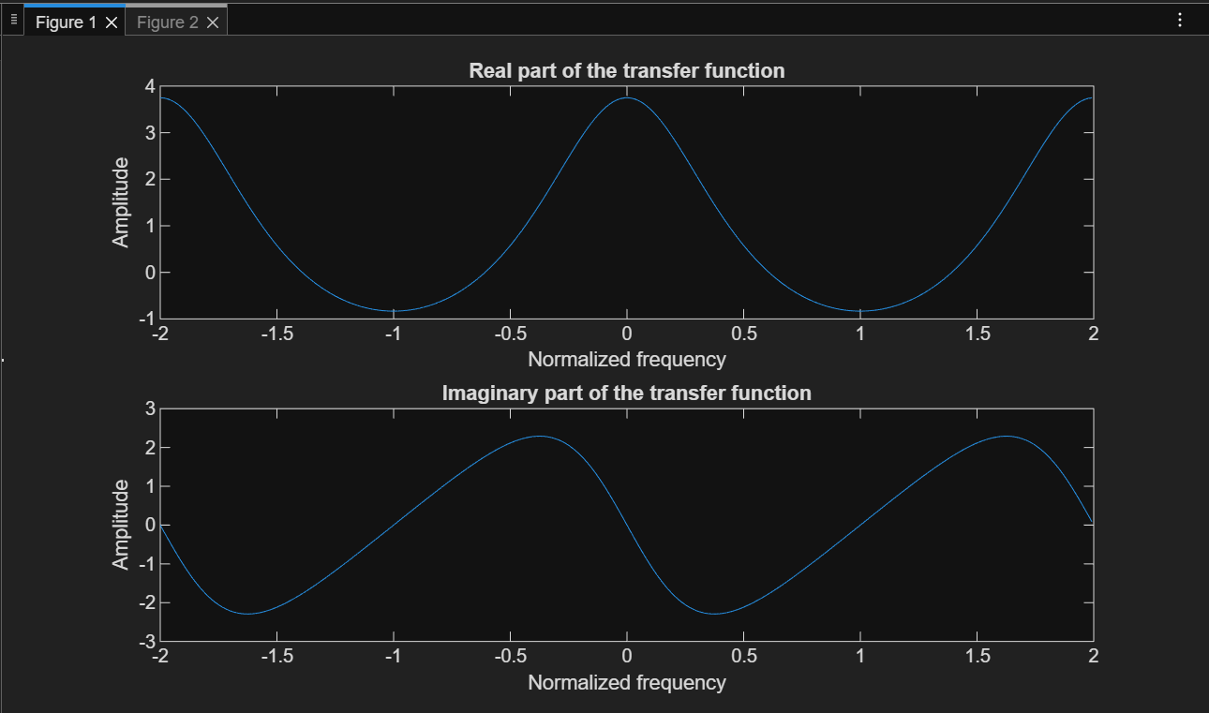
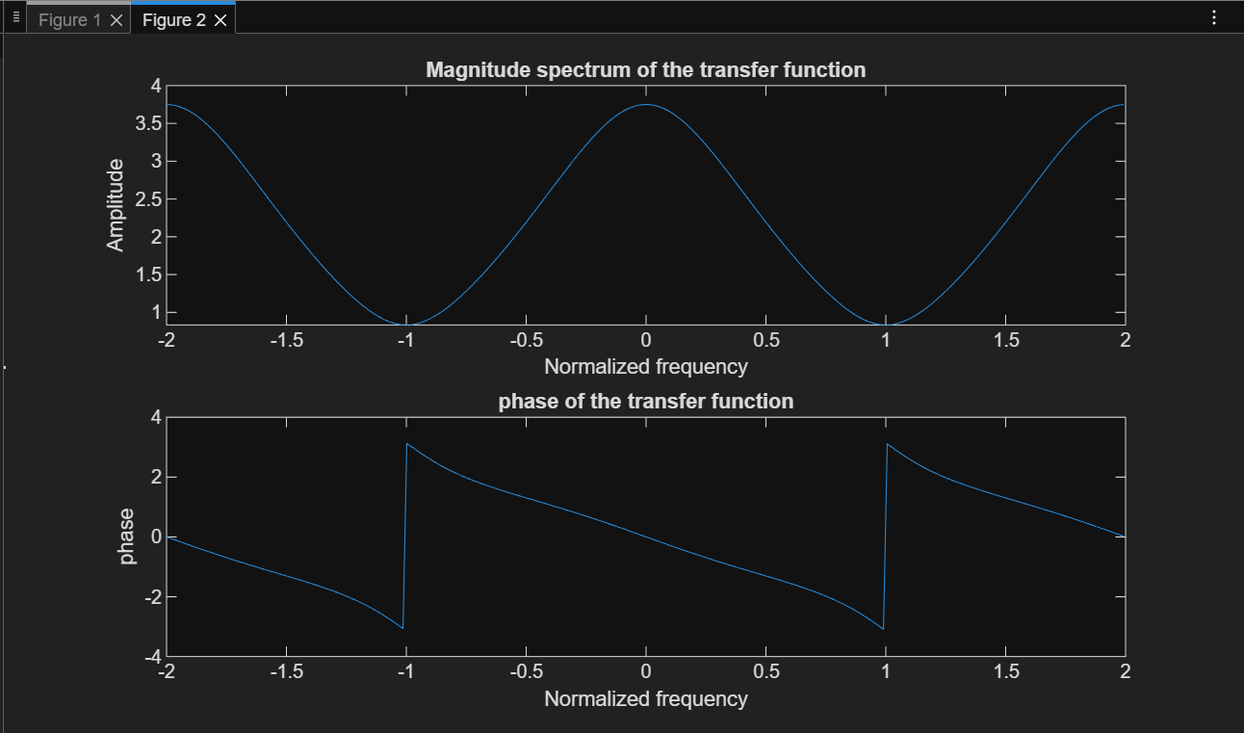
Result:
- Fourier Transform and Inverse Fourier Transform of the given signal were obtained successfully.
- Frequency-domain representation of the rectangular pulse was observed.
- DTFT magnitude and phase responses of the given transfer function were plotted correctly.

Conclusion:
This experiment successfully demonstrated Fourier Transform, Inverse Fourier Transform, and DTFT analysis using MATLAB. These tools are essential for understanding the frequency characteristics of signals and systems.

